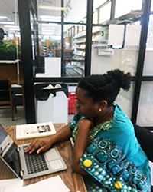

I have always enjoyed coming to the Madison County Library since I have grown up in Canton, MS. Reading is a vital part of education. Now even as an adult, I have in the past and currently spend many hours at the local library. I use their library resources for my children and for my personal and educational use. When my computer crashed, the library saved my life. I always promote the library and their awesome activities/resources; especially to the students and parents in the school district I am employed.   
Thank You Madison County Library Staff for all that you do.  
Pastor Korea L Davis